ISSACK WAITHAKA
cs-sa07-24085

Info sec overview
- It is the practice of protecting data from unauthorized access
- Risk management focus on implementation of policies without negatively affecting an organizations business operations
- Red team focuses on attacking, breaking into an organizations to identify potential vulnerabilities while blue team focuses on defending, by analyzing the risks. Coming up with policies etc.
- A pentester helps an organization identify risks in its networks

Getting started with a pentest Distro
- The choice for a distro is for personal preferences
- We can set up our distro as the base os or dual boot or even install it virtually
- In this module I started the HTB machine to become familiar with it

Staying Organized
- When attacking, we should have a clear folder to save data from the attack
- Note taking is very crucial when doing a pentest. Some of the note taking tools in linux include cherrytree, vscode etc.

Connecting Using VPN
- A virtual private network (VPN) allows us to connect to a private network and acess resources as if we are directly connected to the target private network
- I connected to the HTB vpn
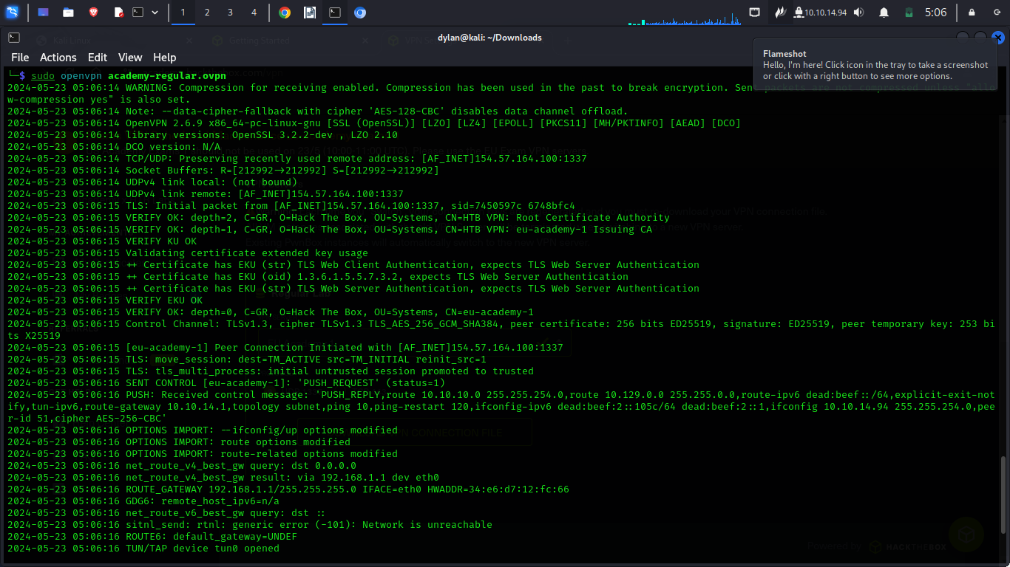
Common terms
- Shell is a program that takes input from the user via a keyboard and passes these commands to the os to perform a specific function
- Bourne Again Shell (Bash) is used as a shell to interact with the OS
- Port are virtual points where network begins and end
- Each port has a number which is used to access specific services or applications running on target devices

Basic tools
- Secure shell(ssh) it a protocol on port 22 that allows access to a computer remotely
- Netcat is a utility for interacting with TCP/UDP ports, but it is mainly used for connecting to shells.
- Vim is a text editor that can be used to write code or editing files

Optional exercise
1.
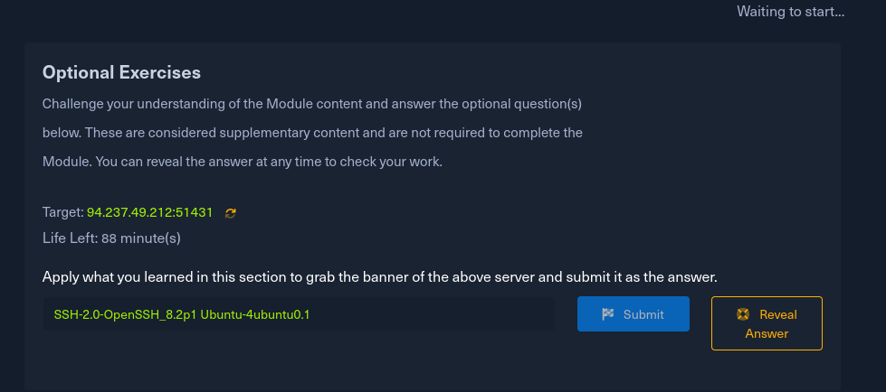
- I ran Netcat to connect to port 51431 which was provided and it sent us a banner
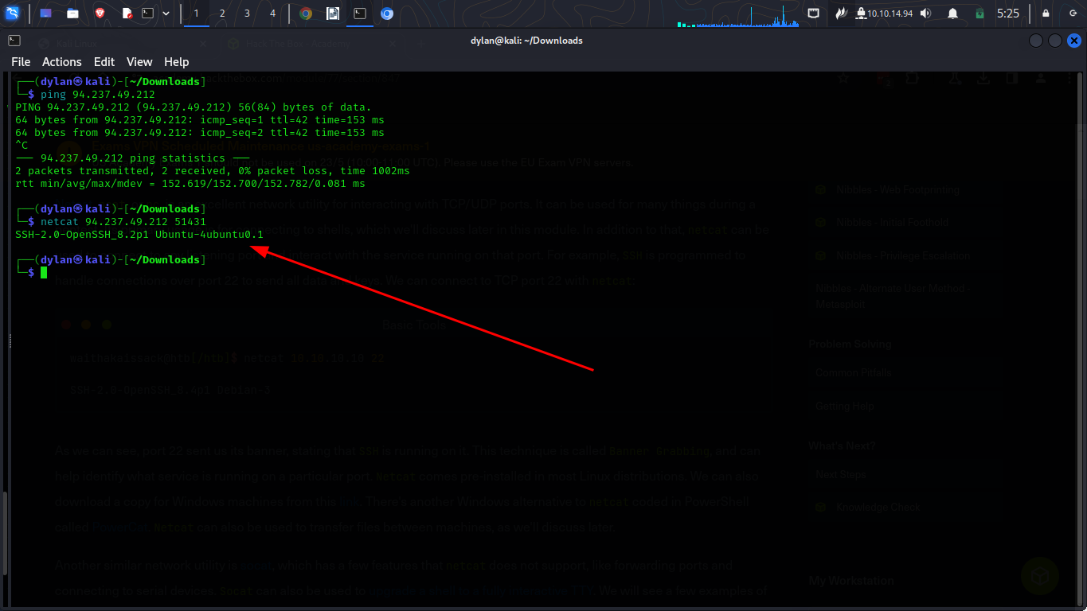

Service Scanning
- Service is a program running on a computer that perform useful functions
- Ips are used to uniquely identify a computer on a networks
- Nmap is one of the tool used to scan and gather more information about a target device
- To specify sripts we use -sC

Questions
1.
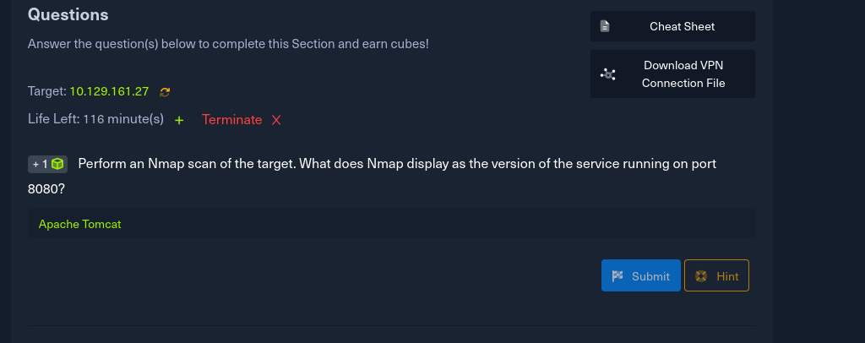
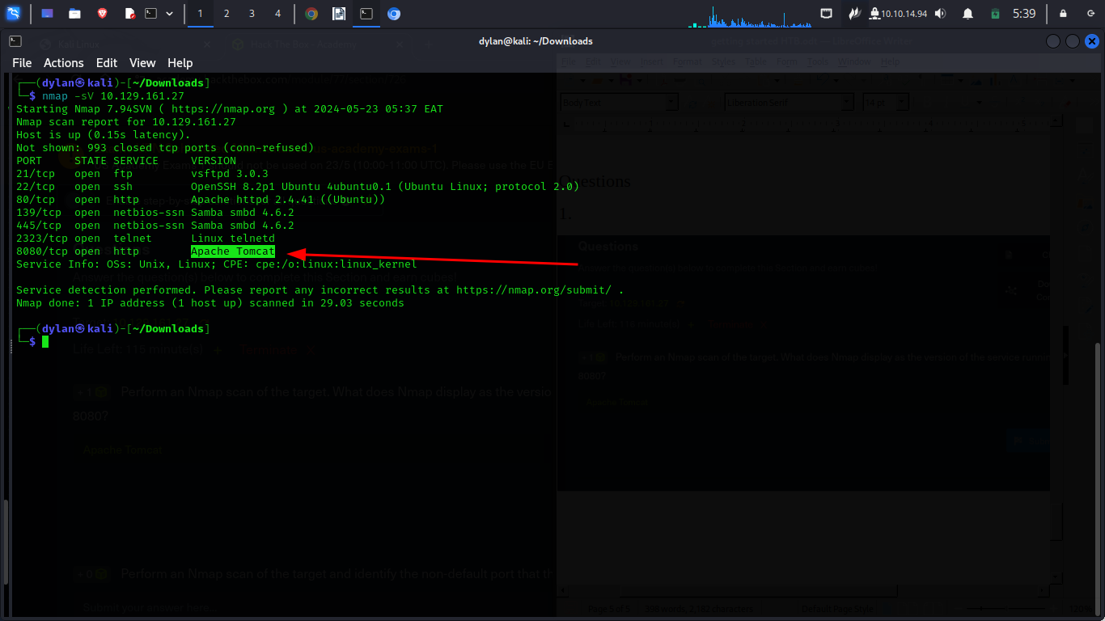
2.
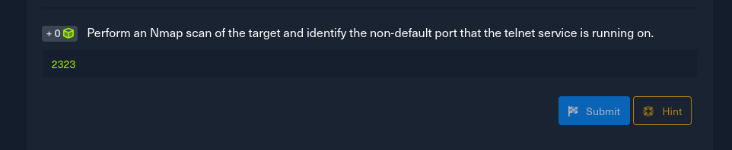
- I perfomed an nmap scan and got
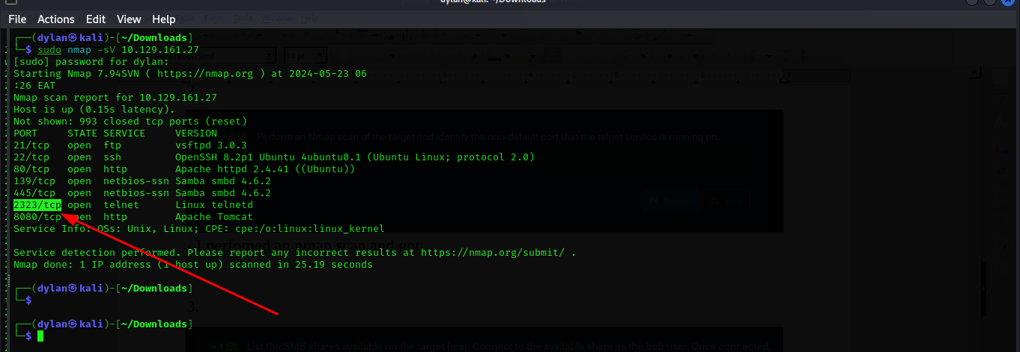
3.
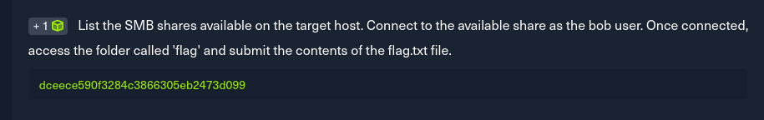
- To list the share available I used
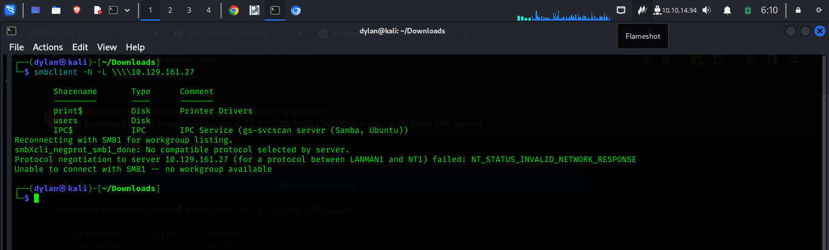
- The next step was to connect available shares to bob, I used Welcome1 as the password which was provided in the notes
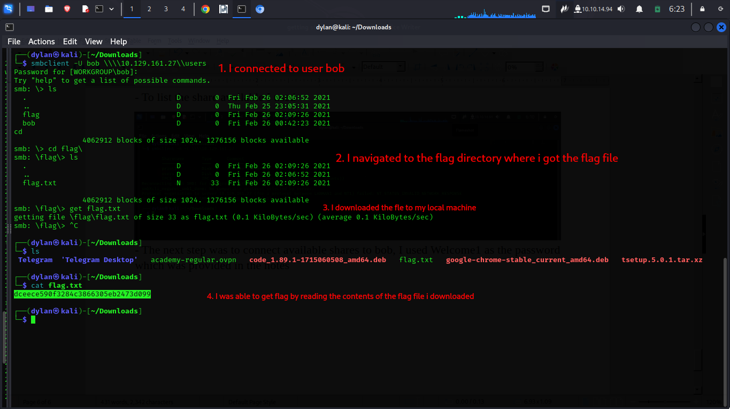
Web Enumeration
- Gobuster or ffuf are tools used to discover hidds directories or files on a webserver.
- gobuster dir -u http://<ip> -w <wordlists>

Questions
1.
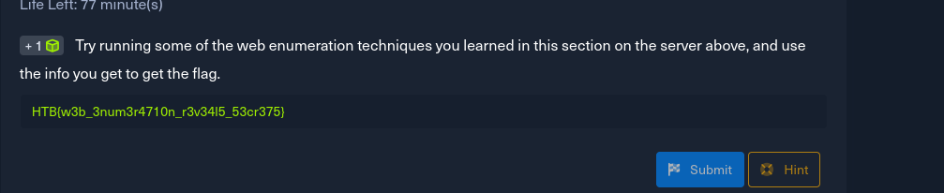
I went to look for files that are not supposed to be accessed which are stored in the robots.txt. I found the admin file page and decided to explore it more futher
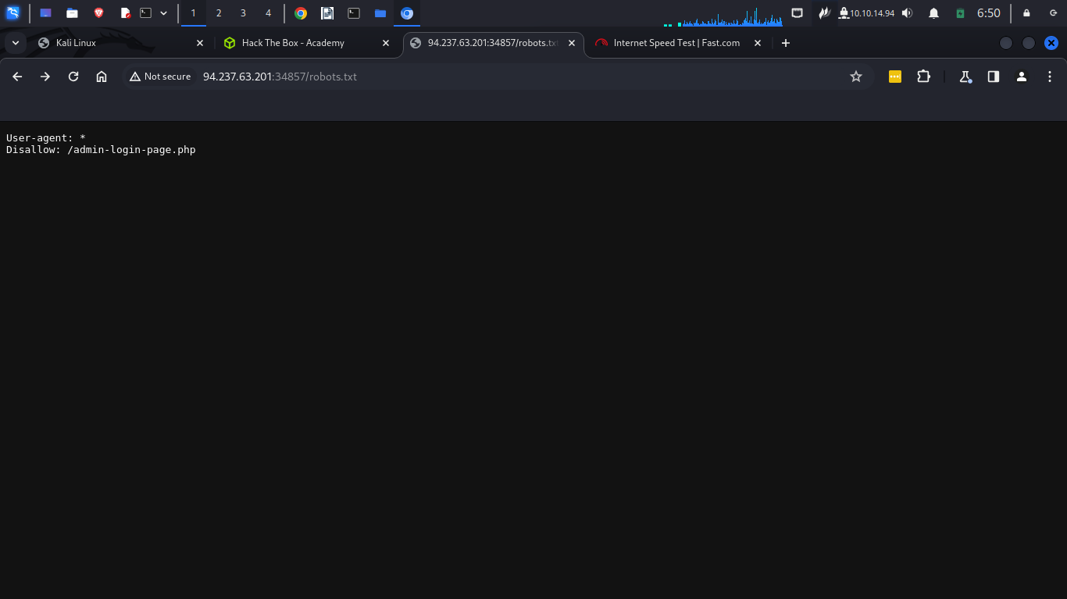
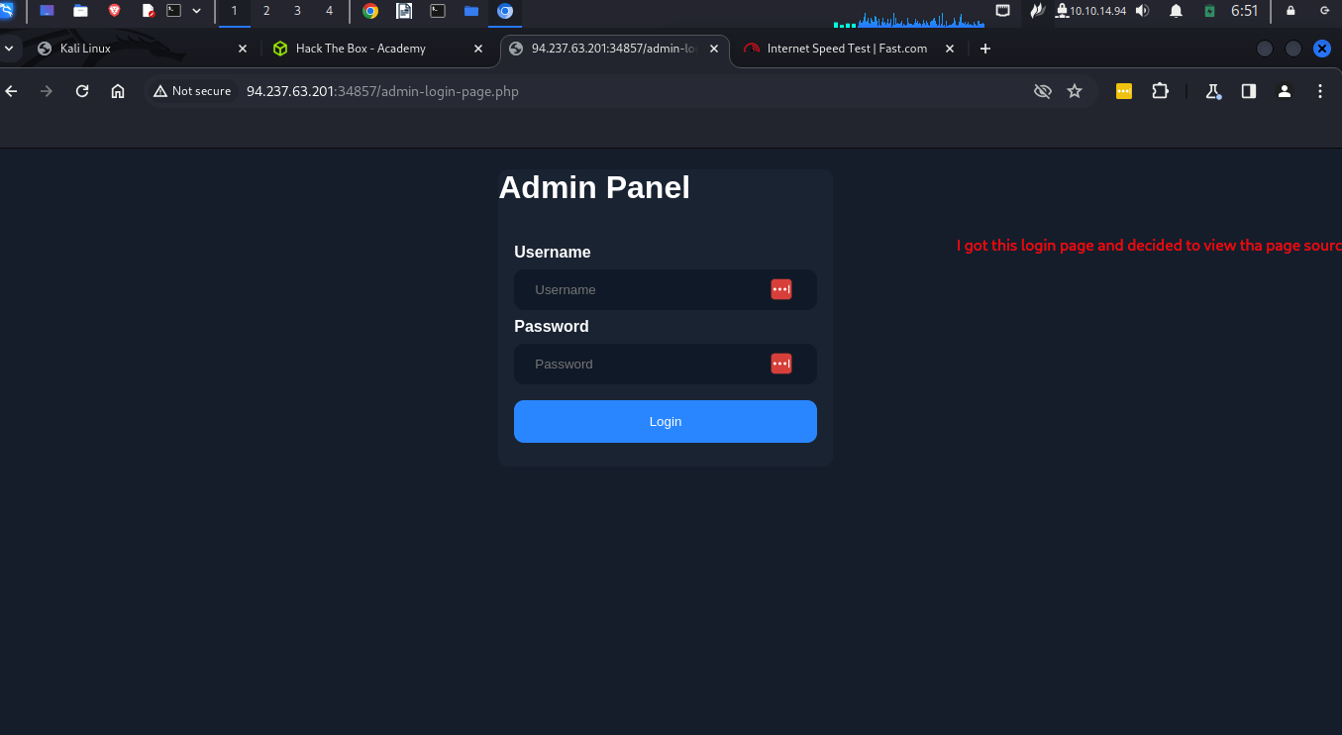

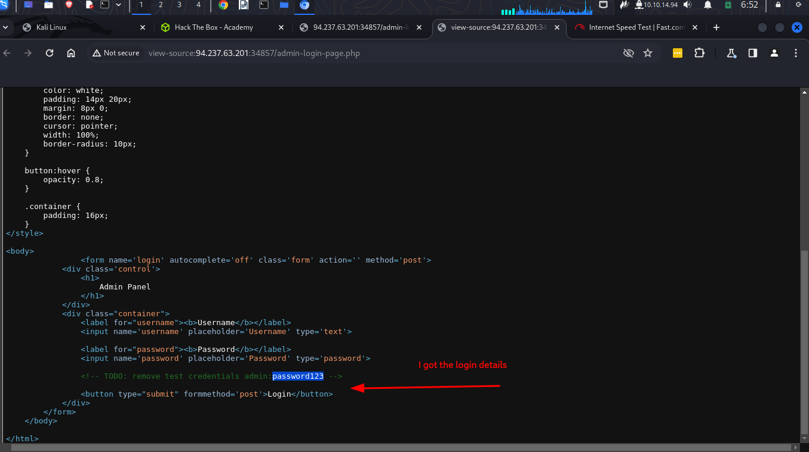
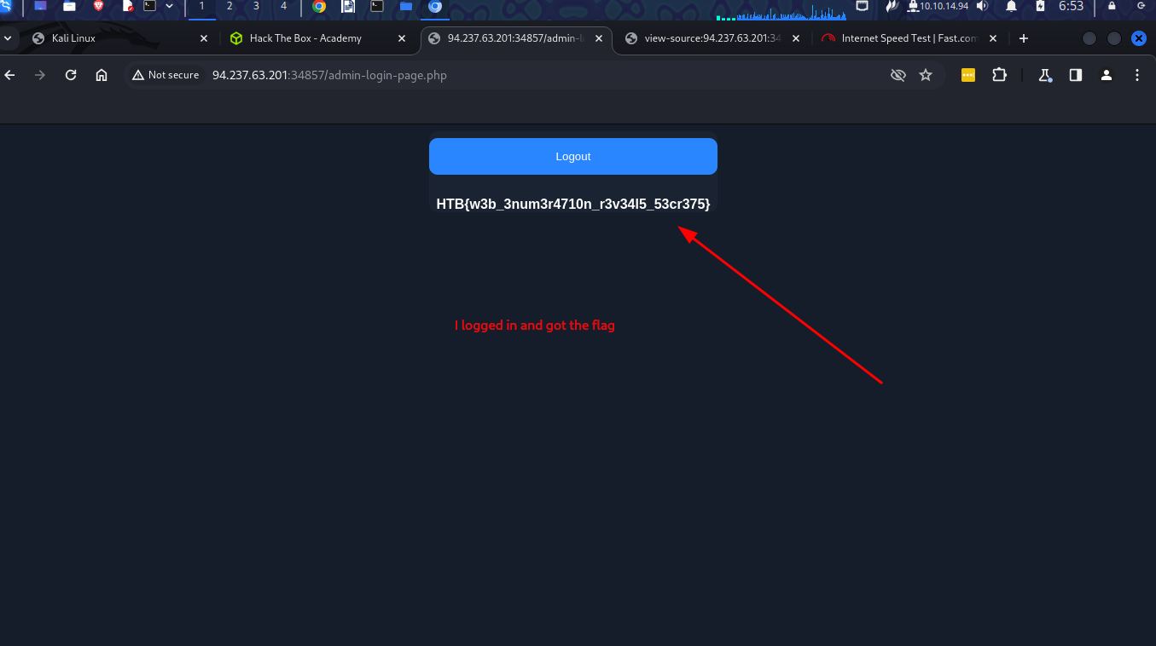

Public Exploits
- After identifying running services in ports using nmap, the next step is to look for any applications/services that have any public exploits
- We can google for the application name with exploit to see any results
- We can also use a tool called searchsploit.
- Metasploit contains many bilt-in exploits for many public vulnerabilities

Questions
1.
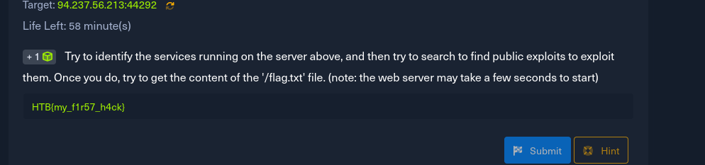
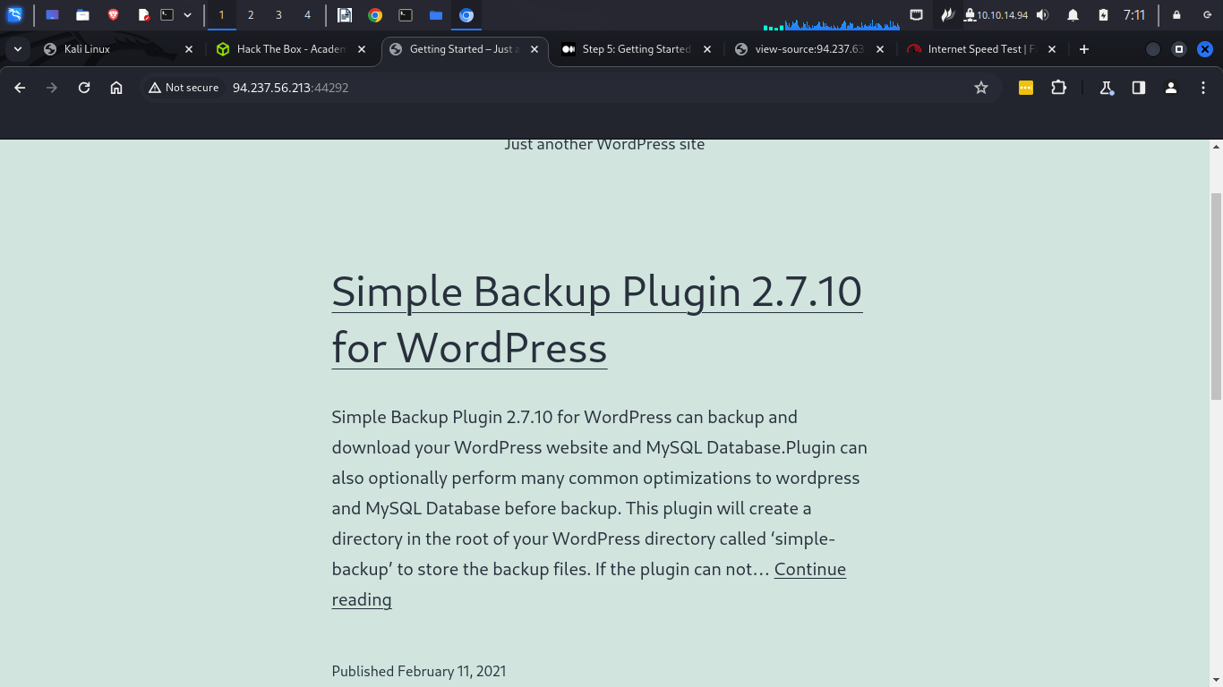
- the ip address took me to this website. A simple plugin 2.7.10
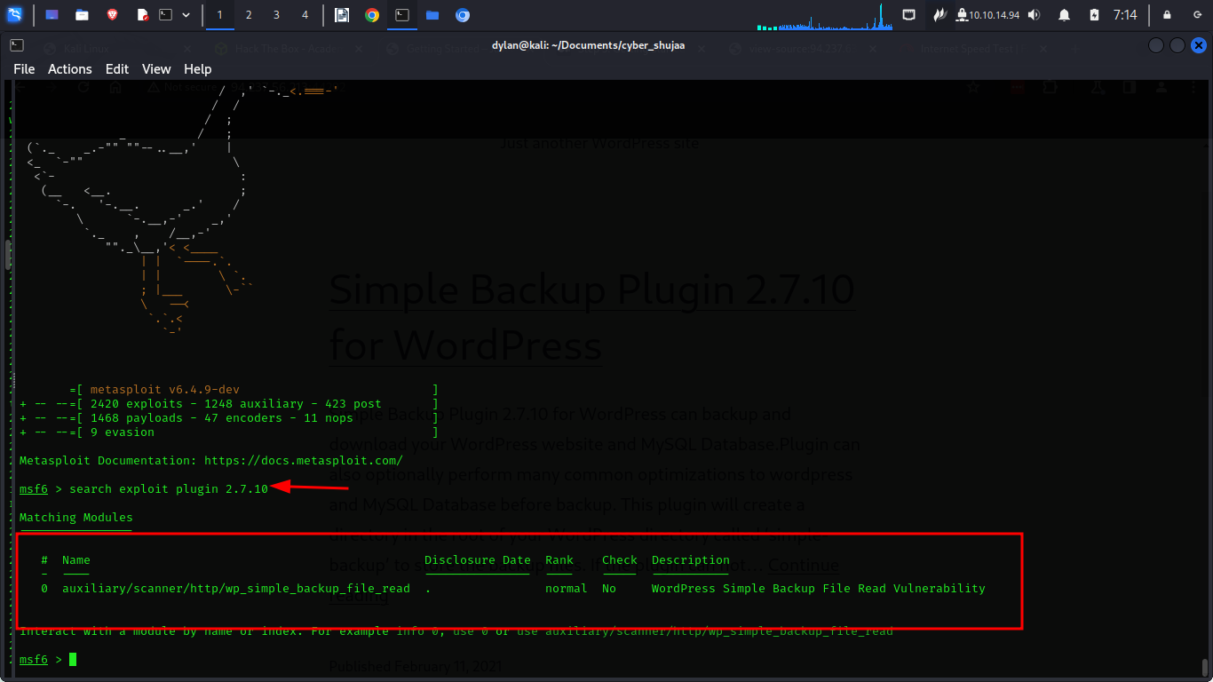
- I went to metasploit to search for any exploit that maybe present and got 1

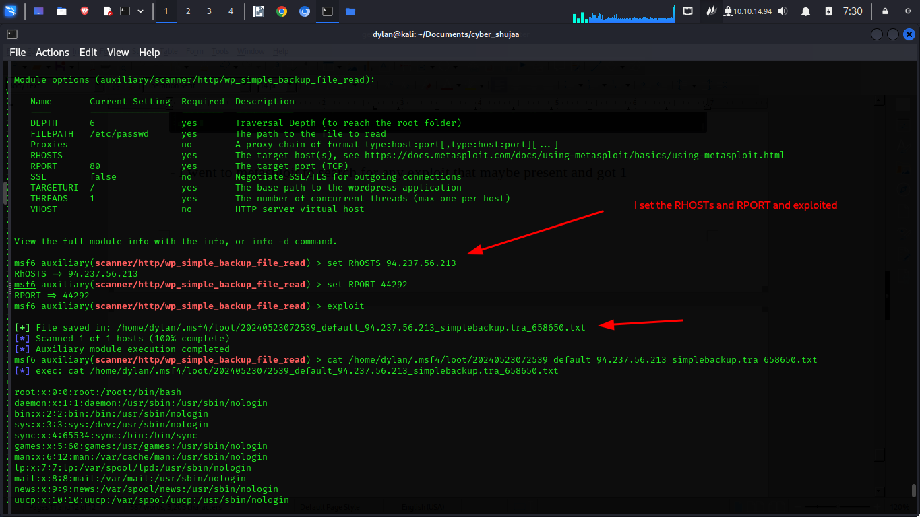
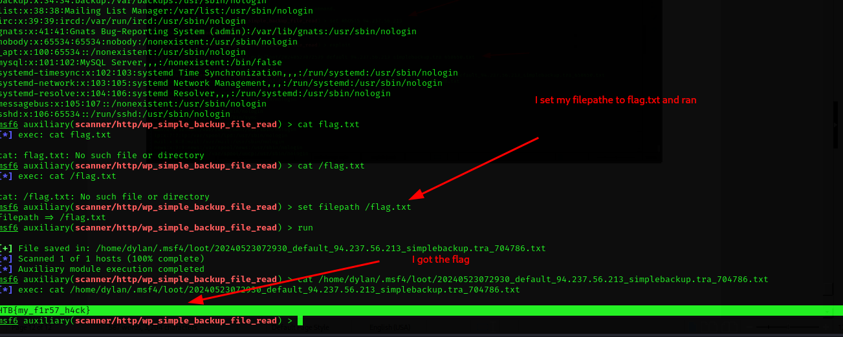

Types of shells
- Can be used as a method of accessing a compromised
- We have:
1. Bind shell which which waits for us to connect to it and gives control once we do
2. reverse shell – connects back to our system and gives us control through a reverse connection
3. Web shell – Communicate through a web server, accepts our commands and execute them and print them back

Privilege Escalation
- This is an attack aiming to gain Unauthorized higher-level acceess within a security system
- If we encounter a server running on an old os we could start by looking for potential kernel vulnerabilities that may exist
- we could do the same for softwares

Questions
1.
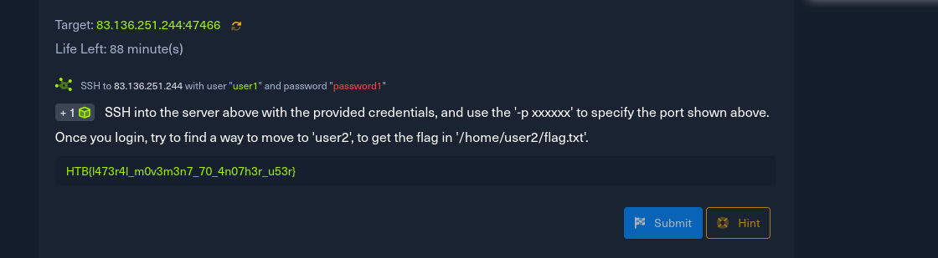
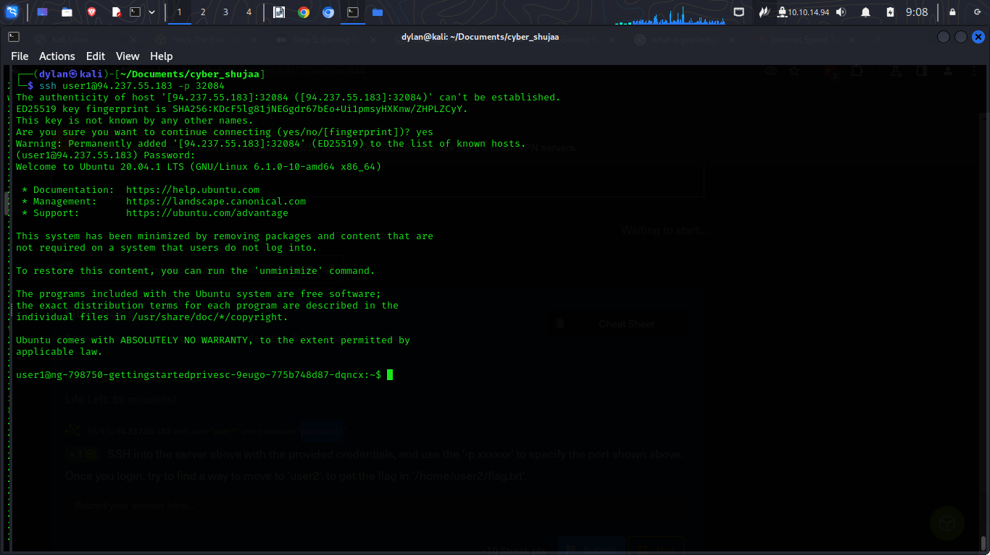
- I was able to login through ssh to the machine
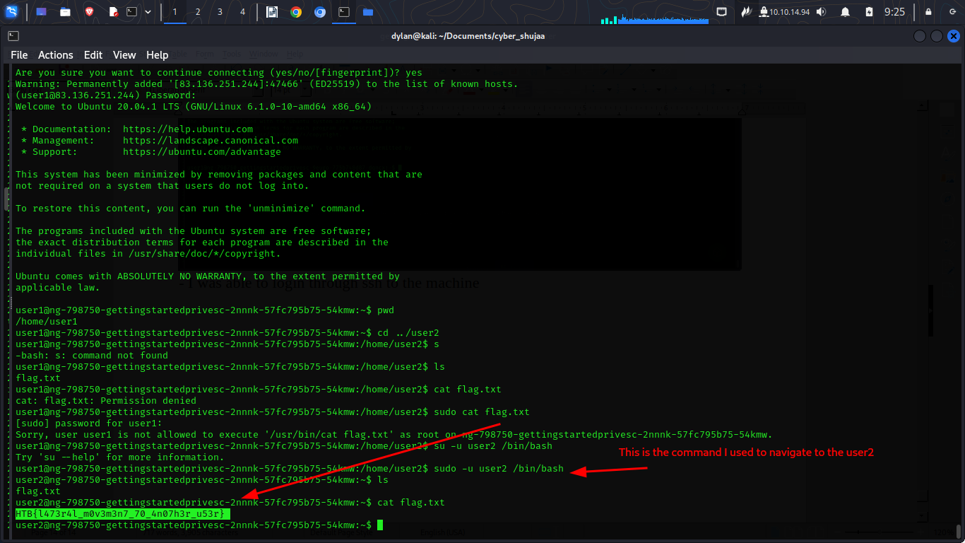

2.
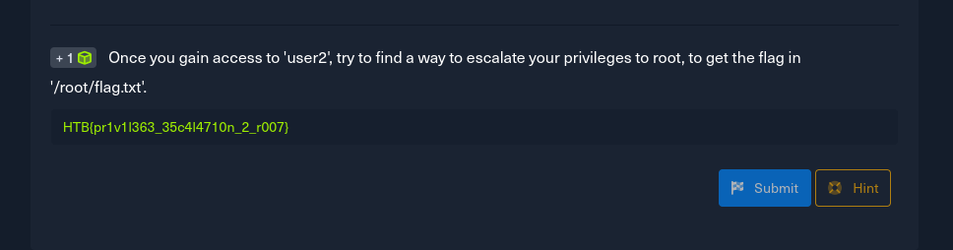
- for this the first step wad to navigate to the ssh directory to find for the private key
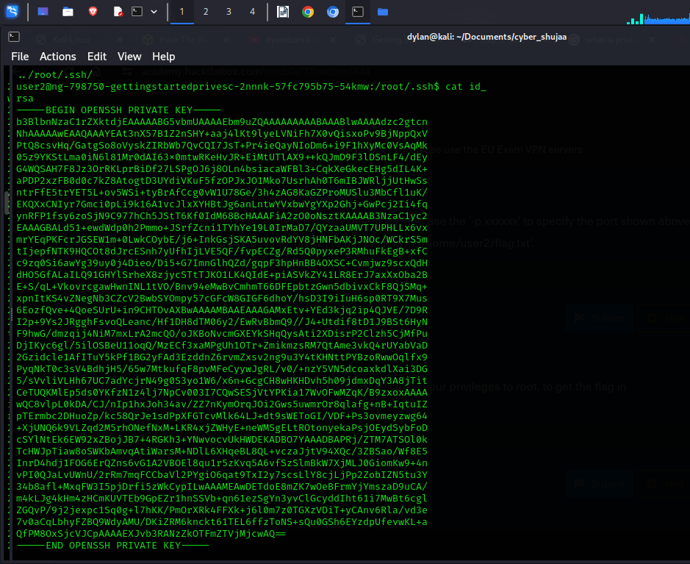
- I copy pasted, saved it to my local machine as id_rsa and change mod to
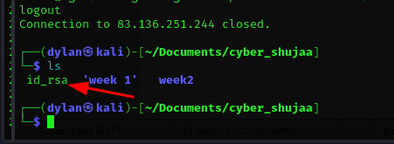

-Then I logged in to root using the key
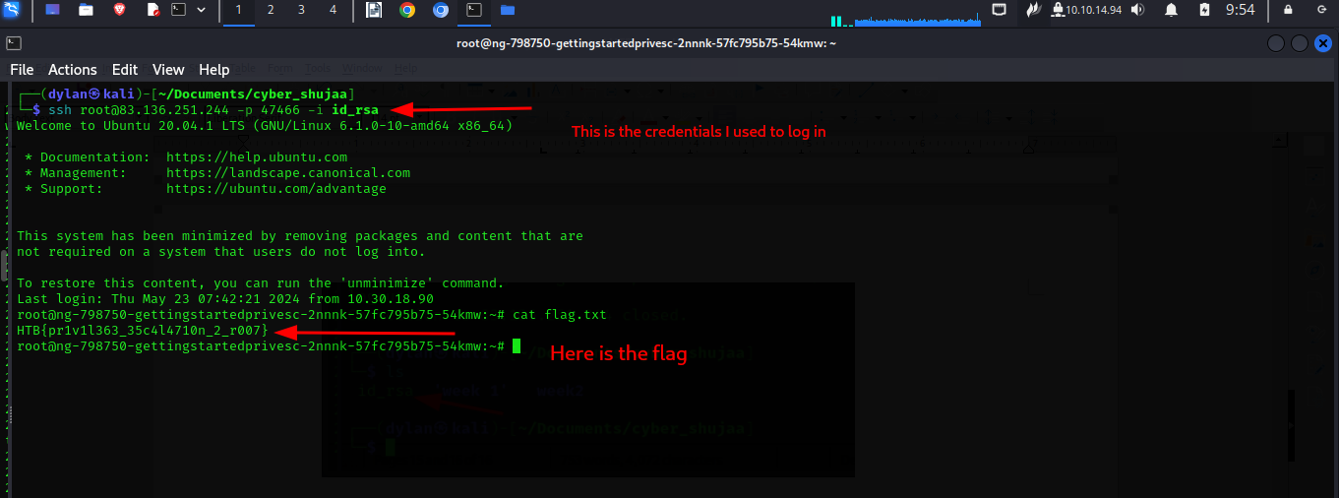

Transferring files
- We can use Python HTTP server then use wget or curl to download files om a remote host
- We can use base64 to bypass a firewall preventing us from downloading a file

Nibbles Unumeration
Questions
1.
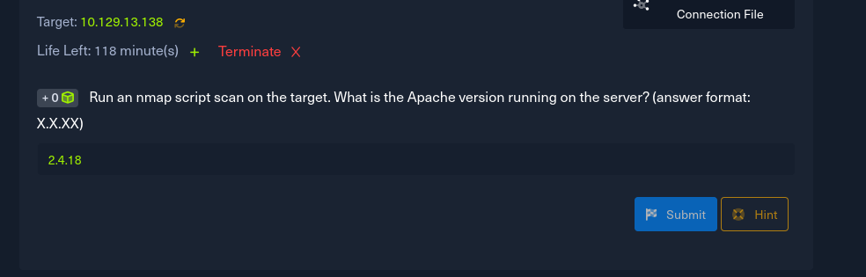
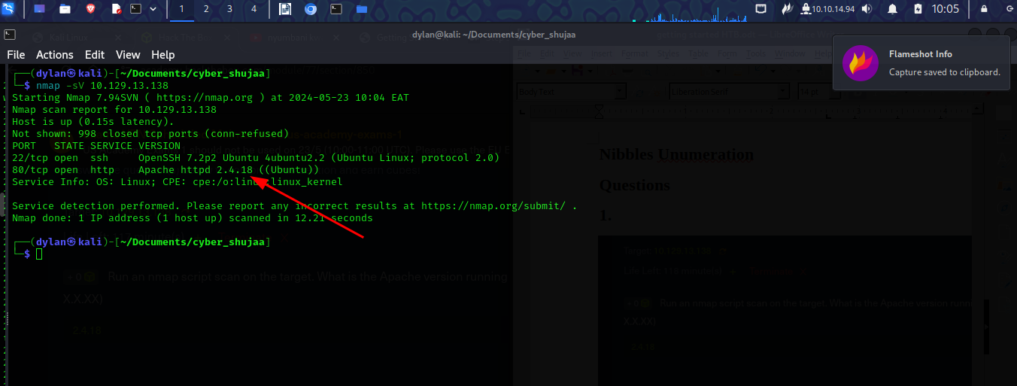
Nibbles – web footprint
- What web is used to identify the web application used
Nibbles – initial Foothold
- I navigated to the ip and got to this page
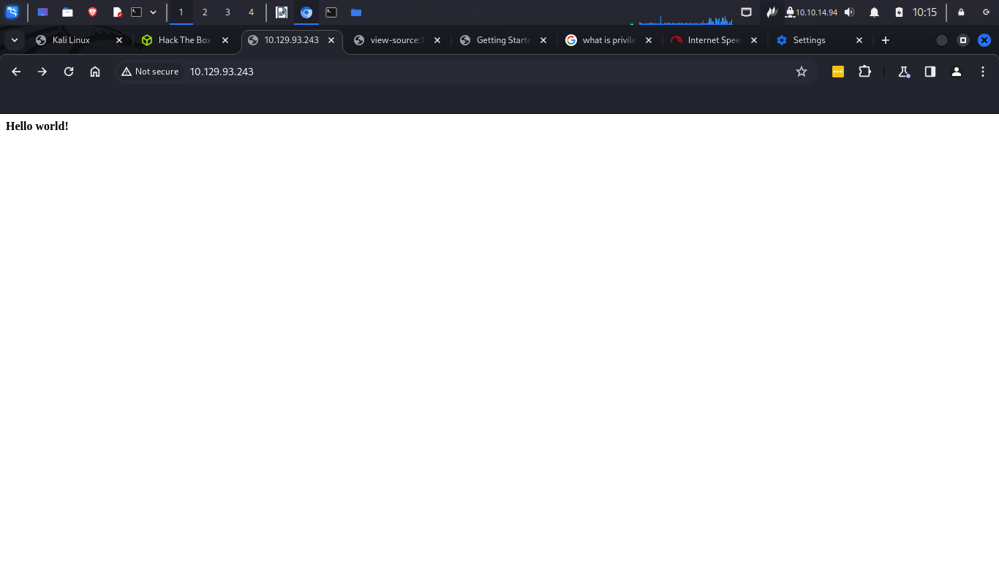

- this was its page source information
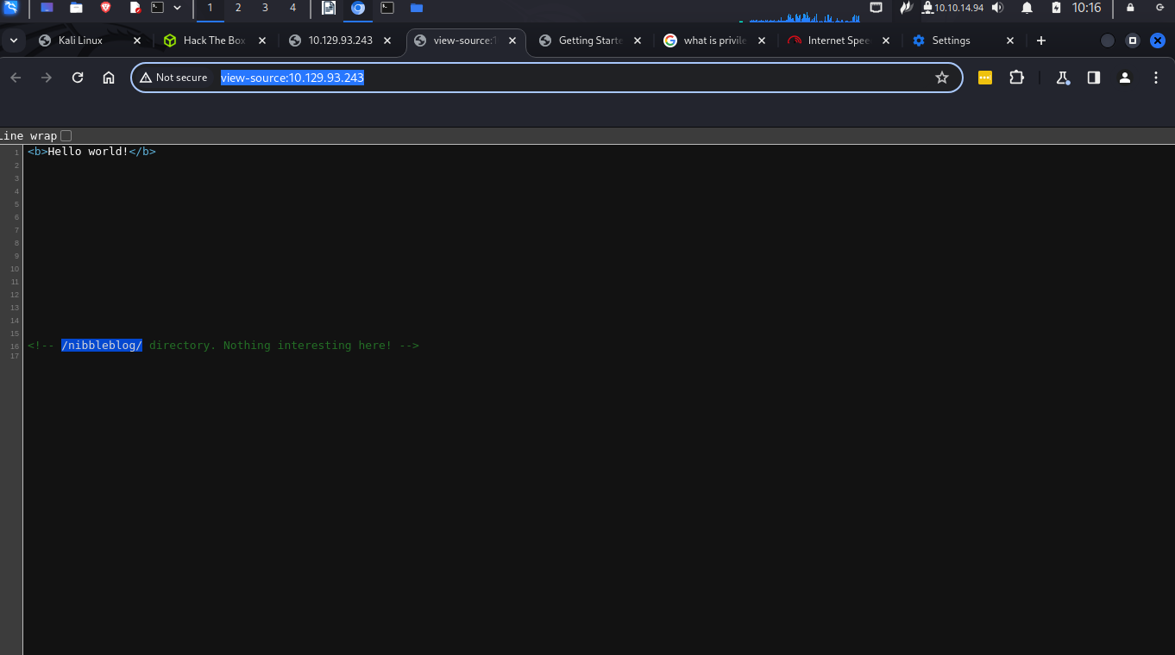
- I navigated to the nibbleblog and was taken to this site
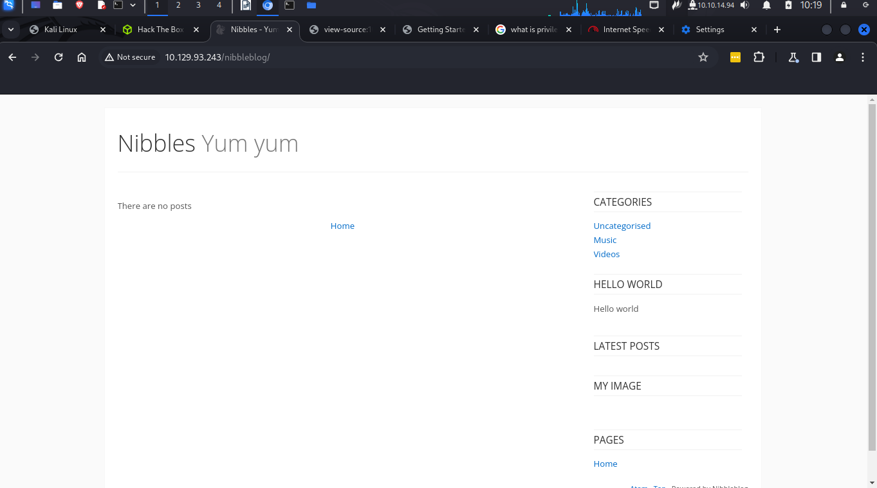
I also did a gorbster search to look for any other hidden directories and this were my results
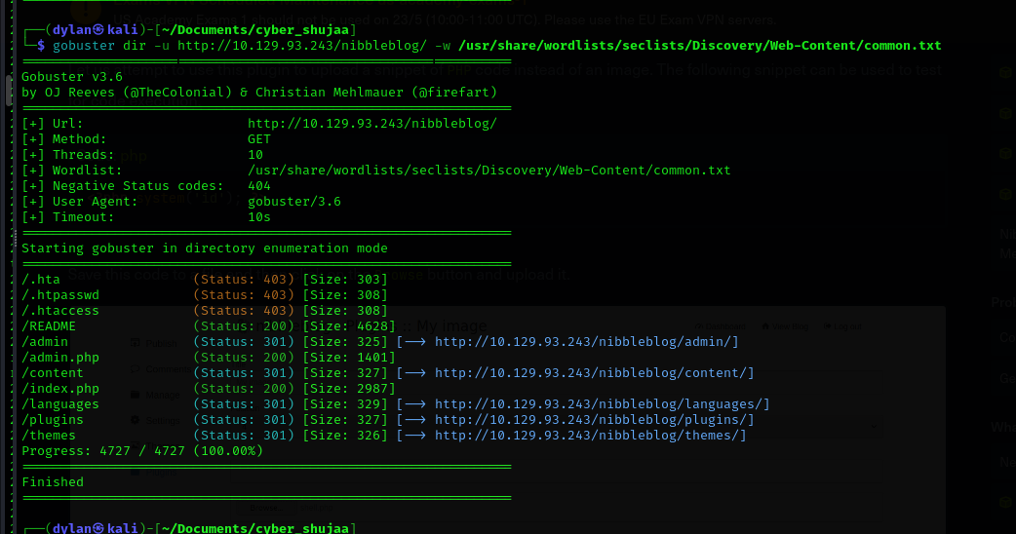
I navigated to the admin.php and found a login page
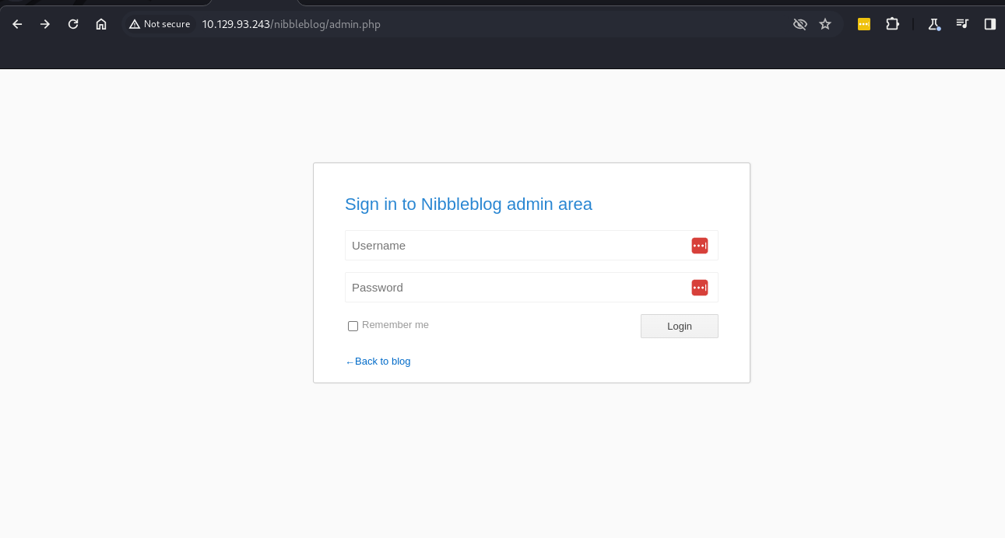
I logged in with the credential username: admin Password: nibbles

question
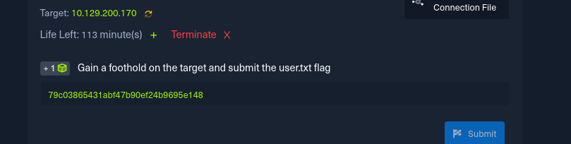
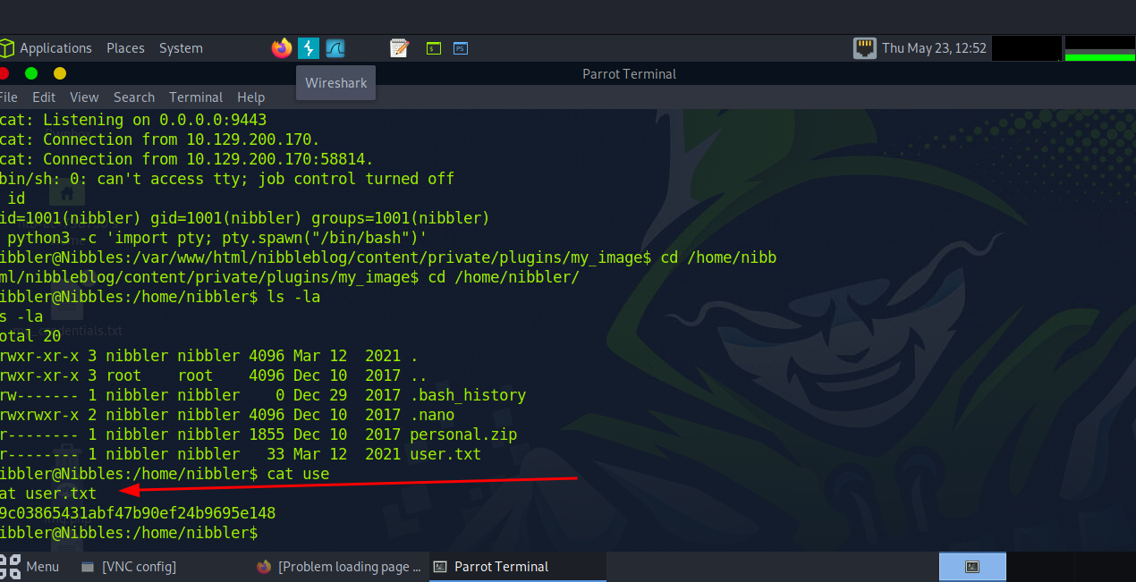

Nibbles Escalation
Questions
1.
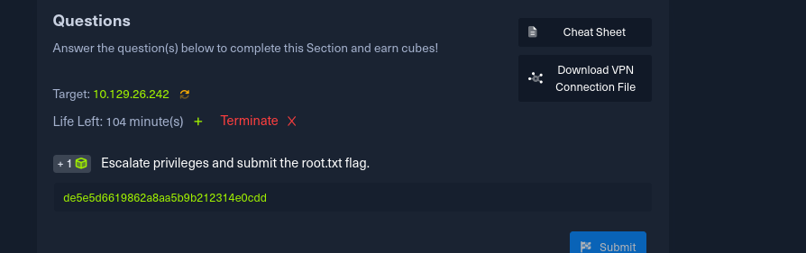
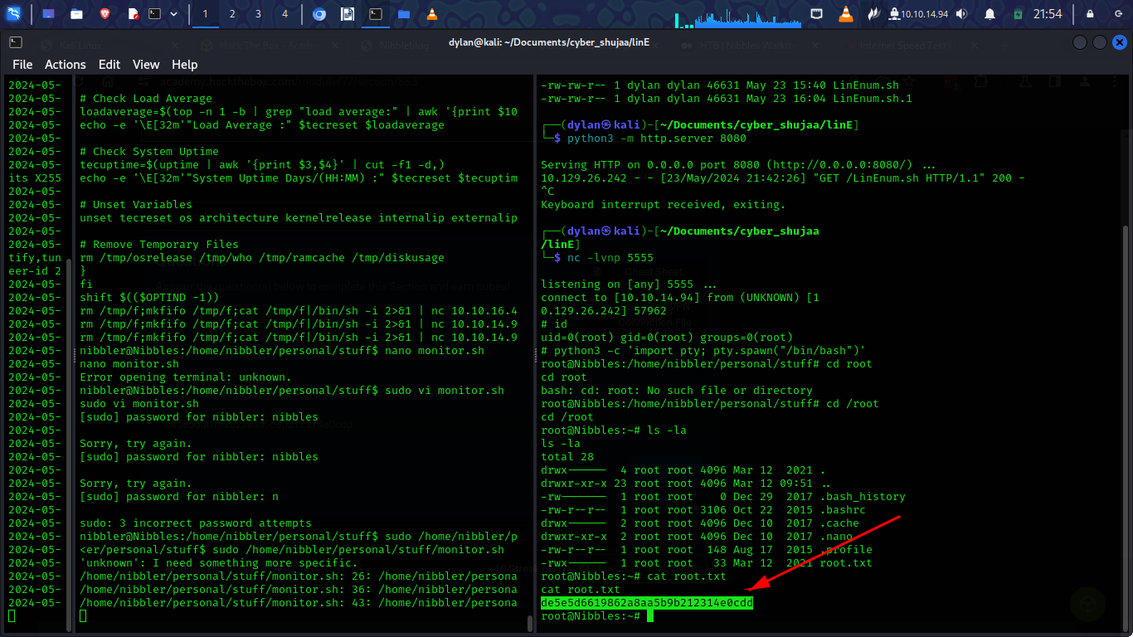
Knowledge check
Questions
1.
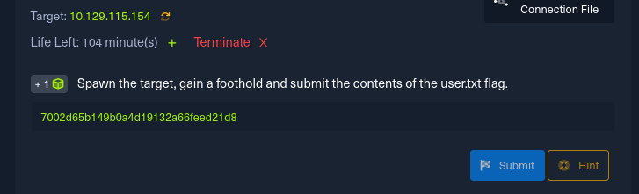
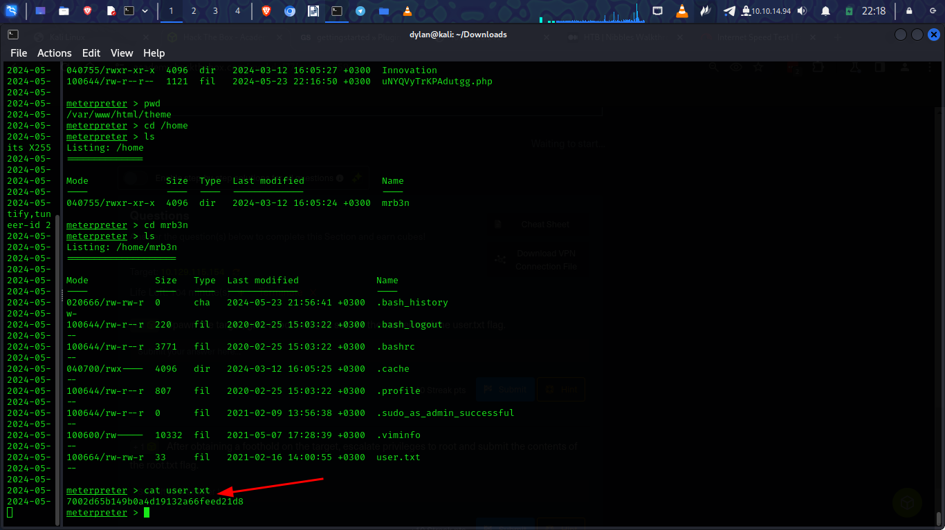
2.


